This is from Assist – they ran a 2 hour Mental Health session for us during the season.

At Assist, we are on a mission to change the current approach to athlete development by educating and training every level of an athletes support system - athlete, coach, parent/support person.

This is **more important now than ever** as pressures rise for youth athletes, parents become more competitive & there is a higher expectation on coaches to provide the correct experience and training to each team they coach. At Assist we have the best of the best providing our programs:

1. Founder & CEO Mikhaela Cann - professional athlete with over 10 years in Australian Programs & WNBL Programs - **WNBL & NBL1 Champion!**

2. Internationally recognised Coach & Coach Mentor - Warwick Cann

3. Sports Psychologist with 20+ Years working with youth - professional athletes and programs - Kirron Byrne

**In July, our 4 hour event includes:**

1. Athletes are provided with both on court and mental skills training that aims to equip them with a toolkit of skills that they can tap into when they need it most - in the face of adversity.

2. Coaches are provided with transformational coaching techniques that encourage coaches to invest in their own development and understand that doing this impacts the longevity and progression of each athlete they coach. They also learn exactly what skills need to be taught at which age and stage as well as critical in-game coaching techniques that we are not taught anywhere else (except youtube).

3. Parents are educated by our program Sports Psychologist on how to best support their child through sport. Again, this is something we are missing in our current system and is often where the 'break down' happens. Many parents believe they are doing the right thing but are not understanding how their actions, behaviours and conversations impact their child & those around them.

4. Q & A with Shaun Brunce (Sydney Kings NBL Champion) & Mikaela Ruef (Townsville Fire WNBL Champion)!!!

Everything we do is to make a difference to the longevity of each athlete associated with our sport and we appreciate your support.

Thank you and we really hope to see you there along with some of your families :)

--

Regards,

Mikhaela Cann

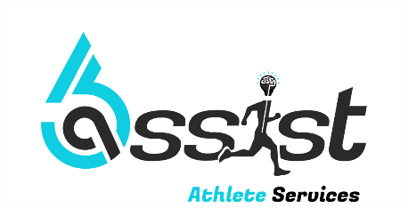

Ph: 0434627234

W: [www.assistathleteservices.com](http://www.assistathleteservices.com)